# MAT 303 Module Three Problem Set Report

Second Order Models

Camilo Hoyos

camilo.hoyos@snhu.edu

Southern New Hampshire University

## **1. Introduction**

The data set that we are exploring is an economic data set related to wage growth and labor force. It contains wage growth rate, inflation, unemployment rate, whether the economy is in or not in recession, and the gross domestic product (GDP) growth rate. The results could be used to predict future wage growth based on GDP growth rate and inflation. I will be running a Quadratic model with one quantitative variable, two quantitative variables, and then one quantitative and one qualitative variable.

## **2. Data Preparation**

The wage growth rate (wage_growth), rate of inflation (inflation), recession (economy), and GDP growth rate (gdp) are all important variables in this data set as they will be used for the subsequent models. These variables will be utilized in the three models that will be created. There are a total of 6 columns and a total of 99 rows.

## **3. Quadratic (Second Order) Model with One Quantitative Variable**

### Correlation Analysis

The rate at which inflation increases based on wage growth looks somewhat linear. However, as wage growth increases it would appear that the rate of inflation increases which would suggest a second order model. Visually one could envision a straight line and if they notice that the scatter plot begins to curve away from the line it would suggest a second order model. We can also see that there is a positive correlation between wage growth and inflation, as inflation increases, wage growth also increases.

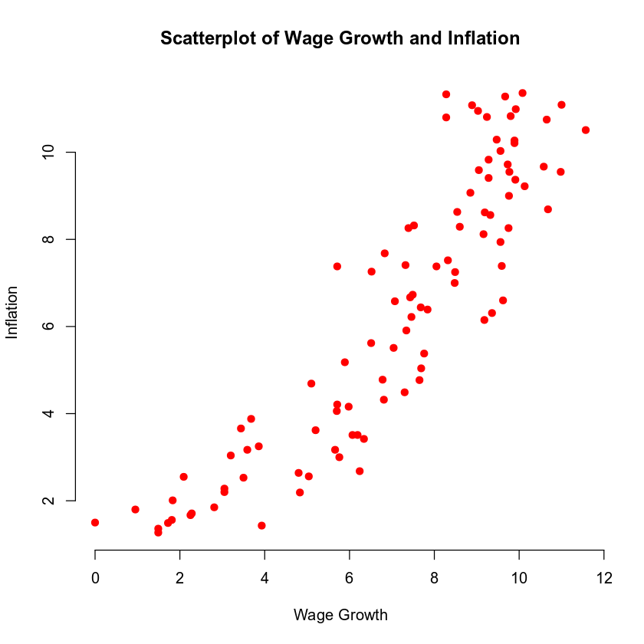

### Reporting Results

The general form of the second order regression model for wage growth related to inflation is: $Y=β+βX+βX{}^{2}$, where Y is wage growth rate and X is inflation rate. The second order regression model equation is: $\hat{Y}= -0.39508+1.81077X-0.08129X{}^{2}$. The coefficient of multiple determination is 0.8614 or 86.14%. This describes that 86.14% of the variability of wage growth rate can be explained by the inflation rate. The adjusted coefficient of multiple determination is 0.8585 or 85.85%. This describes how well the model fits the data provided. The initial value of -0.39508 provides the baseline if inflation rate was set to 0. In terms of inflation, for every unit of inflation, wage growth increases by 1.81077. For every unit that increases the inflation by 1.81077, it also reduces it by -0.08129 and the inflation rate itself squared.

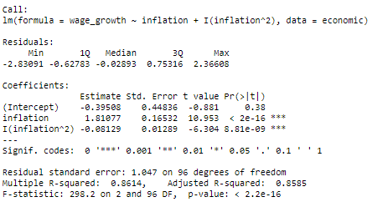

### Evaluating Model Significance

The null hypothesis (H0) is that there is no relationship between wage growth rate and inflation rate. The alternative hypothesis (Ha) is that there is a relationship between wage growth rate and inflation in such that the wage growth rate can be predicted based on the inflation rate. From the F-test we can see that the p-value is 2.2e-16 which is lower than the level of significance threshold of 5%. With the F-test p-value we can reject the null hypothesis and subsequently accept the alternative hypothesis. Based on the T-tests, we can evaluate the significance of each term. The inflation rate has a p-value of 2e-16 and the inflation rate squared has a p-value of 8.81e-09 which are both well under the significance level of 5%.

### Making Predictions Using Model

The predicted wage growth of a labor force that has an inflation rate of 7.41 would be 8.5592%. The 95% prediction interval for wage growth has a fit of 8.5592%, a lower limit of 6.4568%, and an upper limit of 10.6616%. This states that there is a 95% level of confidence that the labor force will have a wage growth rate between 6.4568% and 10.6616%. The 95% confidence interval for wage growth has a fit of 8.5592%, a lower limit of 8.2473%, and an upper limit of 8.871%. This explains that there is a 95% level of confidence that the average wage growth for the labor force with an inflation rate of 7.41 will be between 8.2473% and 8.871%.

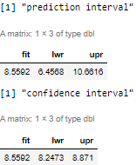

## **4. Complete Second Order Model with Two Quantitative Variables**

### Reporting Results

The general form of a complete second order regression model for wage growth related to inflation and GDP growth is: $Y=β+βX1+βX2+βX1X2+βX1{}^{2}+βX2{}^{2}$ where X1 is the inflation rate, X2 is the GDP growth, and X1X2 is the interaction term between inflation rate and GDP growth rate. The second order regression model for wage growth is $\hat{Y}= -0.395208+1.060687X1+0.545357X2-0.034358X1X2-0.027371X1{}^{2}-0.003176X2{}^{2}$. The coefficient of multiple determination is 0.9113 or 91.13%. This explains that 91.13% of wage growth can be explained by inflation rate, GDP growth, and the interaction term between inflation and GDP growth. The adjusted coefficient of multiple determination is 0.9065 or 90.65%. This states how well the model fits the sample data provided. There is a very high level of correlation and we can assume there is some multicollinearity. The beta estimate for GDP squared is -0.003176. What this provides is that for every unit of GDP growth the wage growth will drop by the unit squared times the coefficient. The beta estimate for inflation squared is -0.027371 which describes that for every unit of inflation, it will decrease for every unit squared times the coefficient.

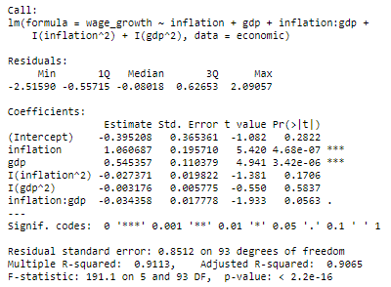

### Evaluating Model Significance

The null hypothesis (H0) is that there is no relationship between wage growth, inflation, GDP growth, and the interaction between inflation and GDP growth. The alternative hypothesis (Ha) is that there is a relationship between wage growth, inflation, GDP growth, and the interaction between inflation and growth such that wage growth can be predicted. The F-test has a p-value of 2.2e-16 which is well within the 5% level of significance. With this evidence we can safely reject the null hypothesis and accept the alternative hypothesis. The T-test provides an evaluation of each variable’s fit in the model. Both inflation and GDP growth fall within a safe range of 4.68e-7 and 3.42e-6 respectively. However, inflation squared, GDP growth squared, and the interaction term do not provide an accurate level of significance at 0.1706, 0.5837 and 0.0563 respectively.

### Making Predictions Using Model

The predicted wage growth if inflation is 7.41 and GDP growth is 9.59 is 8.4579%. The 95% prediction interval has a fit of 8.4579%, a lower limit of 6.744% and an upper limit of 10.1718%. What this provides is that there is, with 95% confidence, that the wage growth of the labor force based on the provided inflation and GDP growth rate will be between 6.744% and 10.1718%. The 95% confidence interval has a fit of 8.4579%, a lower limit of 8.1751% and an upper limit of 8.7407%. With 95% confidence that the average wage growth of the labor force with an inflation rate of 7.41 and GDP growth rate of 9.59 will be between 8.1751% and 8.7407%.

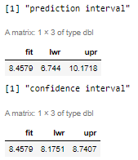

## **5. Complete Second Order Model with One Quantitative and One Qualitative Variable**

### Reporting Results

The general form of the complete second order regression model for wage growth related to inflation and economy is: $Y=β+βX1+βX2+βX1X2+βX1{}^{2}+βX1{}^{2}X2$ where X1 is inflation, X2 is whether the economy is in a recession or not, and X1X2 is the interaction between inflation and whether the economy is in a recession or not. The second order regression model for wage growth is: $\hat{Y}=1.38806+1.33488X1-3.48576X2+1.4144X1X2-0.05175X1{}^{2}-0.163X1{}^{2}X2$. The coefficient of multiple determination is 0.8738 or 87.38%. This provides qualification of how predictable wage growth can be related to inflation and the recession qualitative term. The adjusted coefficient of multiple determination is 0.867 or 86.7%. This identifies how well the model fits the sample data used to generate it.

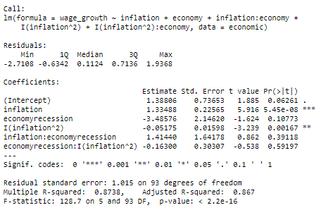

### Evaluating Model Significance

The null hypothesis(H0) is that there is no relationship between wage growth, inflation, and the economic qualitative term. The alternative hypothesis(Ha) is that there is a relationship between wage growth, inflation, and the economic qualitative term where the wage growth can be predicted. The F-test provides a p-value of 2.2e-16 which passes the 5% level of significance and we can therefore reject the null hypothesis and accept the alternative hypothesis. The individual terms have their individual T-tests to determine significance. The two terms that pass the T-test are inflation and inflation squared at 5.45e-8 and 0.00167 respectively. All terms that contain the economic qualitative term fail with T-tests of 0.10773, 0.39118, and 0.59197. In the end, the inflation passes the 5% level of significance and all terms with the economic qualitative term fail the 5% level of significance test.

### Making Predictions Using Model

If the inflation is 7.41 and the economy is not in recession the predicted wage growth is 8.4379%. The 95% prediction interval for wage growth has a fit of 8.4379%, a lower limit of 6.3961% and an upper limit of 10.4796%. This describes that there is a 95% confidence level that with an inflation of 7.41% and when the economy is not in recession the labor force wage growth will be between 6.3961% and 10.4796%. The 95% confidence interval for wage growth has a fit of 8.4379%, a lower limit of 8.1175% and an upper limit of 8.7582%. This explains that, with a 95% level of confidence, that the average wage growth of the labor force with an inflation of 7.41 and no economic recession would be between 8.1175% and 8.7582%. The prediction interval is wider than the confidence interval as it takes uncertainty into consideration such as regression error.

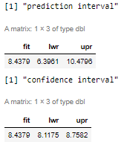

## **6. Conclusion**

I would use the first model which only utilized inflation as a predictor variable. The other models contained several variables that failed the T-test level of significance and high F-test that multicollinearity is apparent. Because of this, the variables could skew predictions. The first model also had a safer F-test p-value of 85.85%. What this model means is that it would be possible to predict what the labor force wage growth rate would be based on the inflation rate. More importantly, we have confirmed that the use of other variables such as whether the economy is in recession or not, or GDP growth could potentially provide inaccurate predictions. What we also know is that inflation has a positive correlation with wage growth, and as wage growth increases, so does inflation.

The practical importance of the analyses that were performed helps compare each of the variables we’ve evaluated to determine what variables passed a 5% level of significance and which did not. Additionally we have the capacity to predict wage growth in relationship with the inflation rate. If someone was tasked with identifying the labor force wage growth based on a predicted inflation rate change, one could use equation provided in the first model: $\hat{Y}= -0.39508+1.81077X-0.08129X{}^{2}$.